

Abstract

To visualize monthly sales performance by product segment and product category to help identify the segments and categories that have met or exceeded their sales targets.

**Sales Performance Analysis**

***Visualization using Tableau- Question***

**Presented by: Ankita Agarwal**

**Business Scenario:**

Mike Goodman, the head of Product Management of a retail products company, is responsible for determining which products his company should continue to offer for sale and which products should be discontinued from the company’s product catalog. Mike wants to build a dashboard that will present monthly sales performance by product segment and product category to help him identify the segments and categories that have met or exceeded their sales targets, as well as those that have not met their sales targets.

**Overview:**

1. Use the Saved Sample – Superstore dataset.
2. Create a bullet chart with Category and Segment dimensions and Sales measures.
3. Blend the data with the Saved Sample - Sales Target data set to bring in the Sales Target measure.
4. Color code the chart to identify Categories and Segments that are above or below target.
5. Add the year of sales to the view to identify trends and outliers.
6. Add a filter so that the user can select one, more than one, or all years.

**Visualizations and Interpretations:**

1. **Overview:**

In the year 2015, Furniture from the Home Office segment could not meet the assigned sales target and performed badly. Also, Office supplies from the same segment under performed in the year 2016.

Sales under the Technology category has always performed well over target over the years.

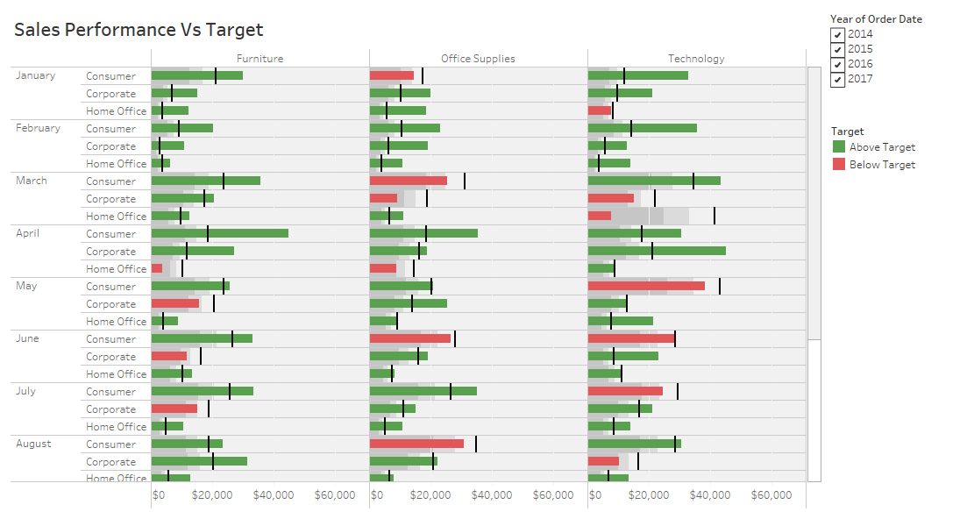

1. **Year 2014**

All the categories and segments have sales above targets in all months except for technology in home office in the month of March and November.

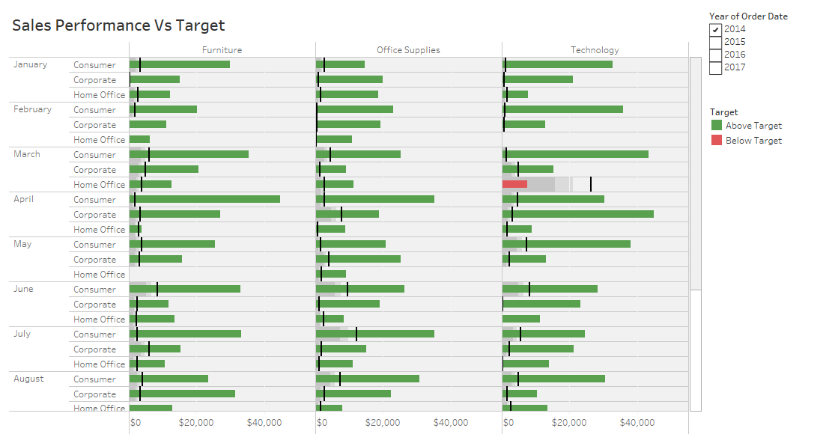

1. **Year 2015**

All the categories and segments have sales above targets in all months except for technology and furniture in home office in the month of November and December respectively.

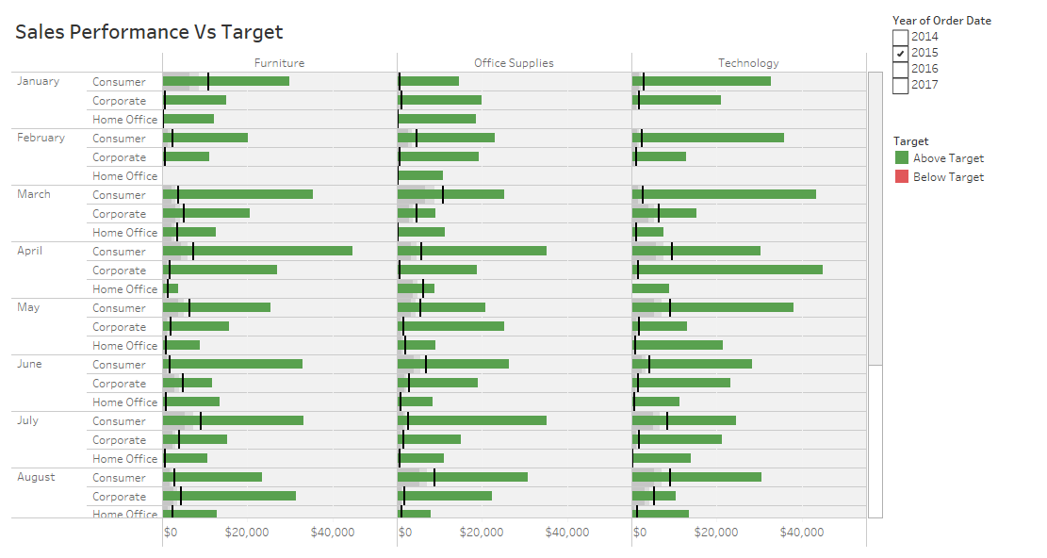

1. **Year 2016**

All the categories and segments have sales above targets in all months except for technology in home office in the month of March and in corporate in October.

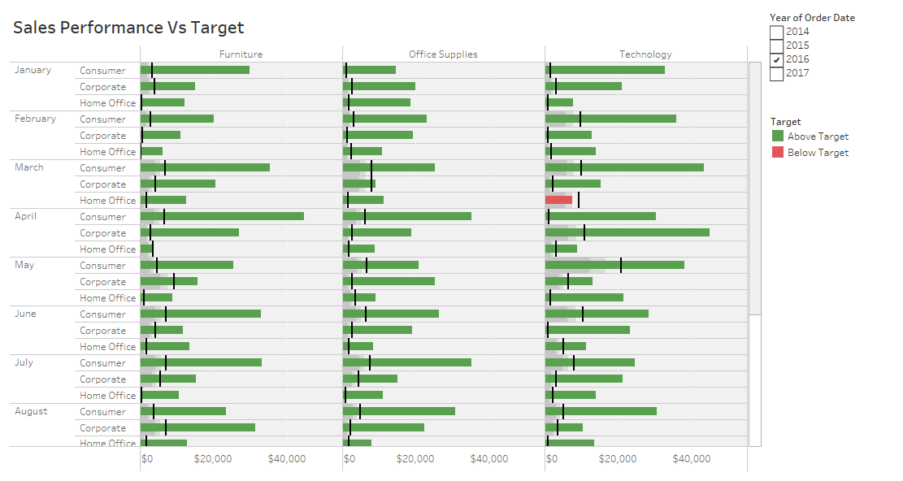

1. **Year 2017**

All the categories and segments have sales above targets in all months except for furniture in home office and office supplies in corporate and home office segments in the month of November.

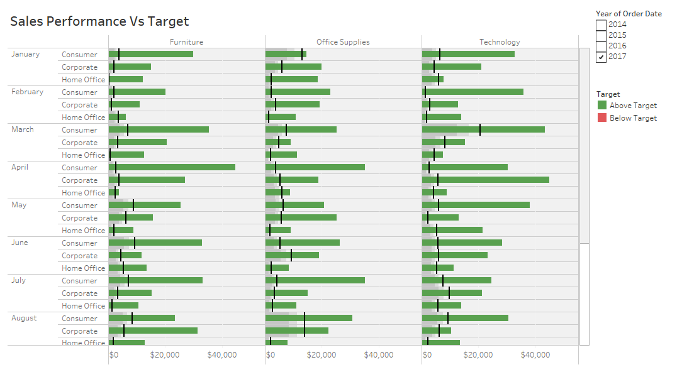

-------------------------------------------------------------------The End-------------------------------------------------------------------